|  |  |  |  |
| --- | --- | --- | --- |
|  | | | |
| **Expt. No:** | | **13** | **High Pass and Low Pass Filters** |
|  | | |
| **Date:** | **26/11/2020** | |
|  | | | |

**Aim:**  To study, design and implement:

1. Passive RC – High Pass Filter
2. Passive RC – Low Pass Filter
3. Observe the Working of Low Pass Filter as an Integrator
4. Observe the working of High Pass Filter as a Differentiator

**SOFTWARE TOOLS / OTHER REQUIREMENTS:**

1. Multisim Simulator/Circuit Simulator

# Theory:

Filters may be classified as either digital or analog.

**Digital filters** are implemented using a digital computer or special purpose digital hardware.

**Analog filters** may be classified as either passive or active and are usually implemented with R, L, and C components and operational amplifiers.

An **Active filter** is one that, along with R, L, and C components, also contains an energy source, such as that derived from an operational amplifier.

A **Passive filter** is one that contains only R, L, and C components. It is not necessary that all three be present.

L is often omitted (on purpose) from passive filter design because of the size and cost of inductors – and they also carry along an R that must be included in the design.

It will be shown later that the ideal filter, sometimes called a “**brickwall**” filter, can be approached by making the order of the filter higher and higher.

The order here refers to the order of the polynomial(s) that are used to define the filter.

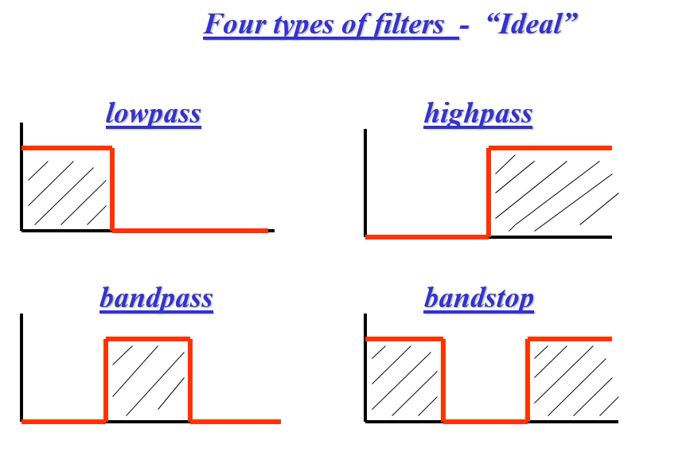

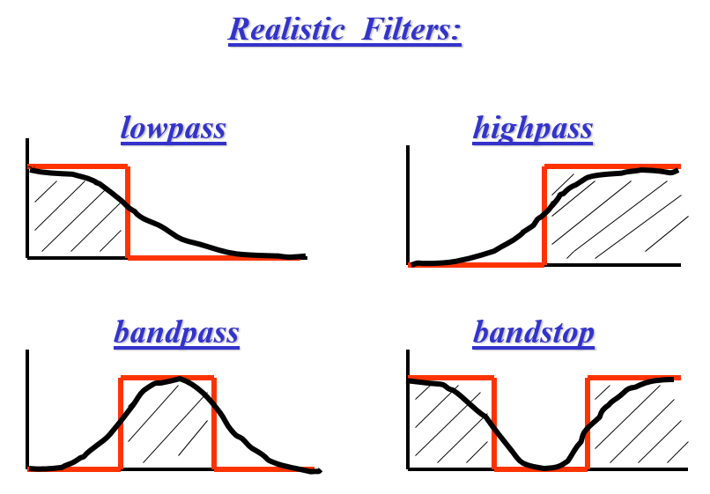

**(A) RC LOW-PASS FILTER**

A low-pass filter allows for easy passage of **low-frequency signals** from source to load, and difficult passage of **high-frequency signals**.

The cutoff frequency for a low-pass filter is that frequency at which the output (load) voltage equals 70.7% of the input (source) voltage.

Above the cutoff frequency, the output voltage is lower than 70.7% of the input, and vice versa.

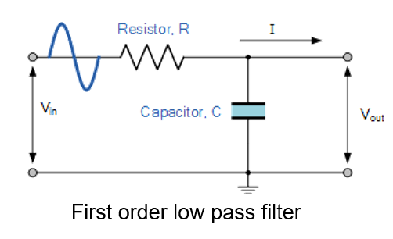

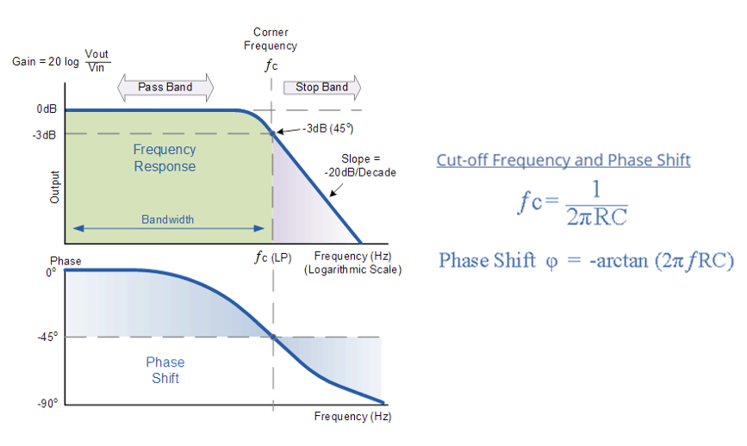

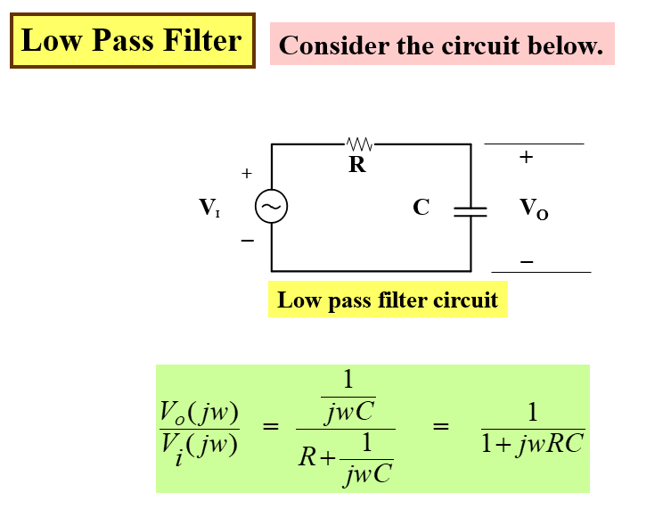

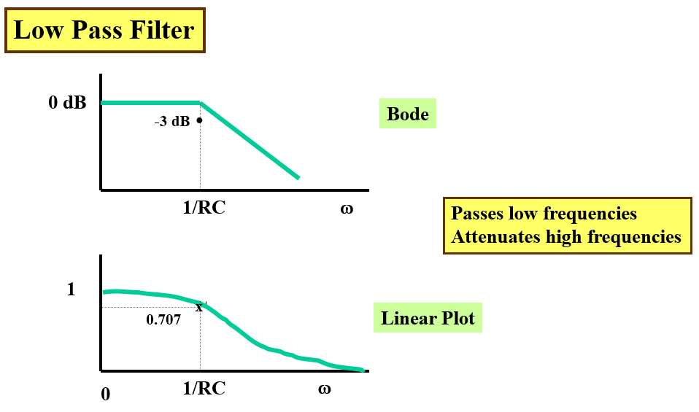

**(B) RC HIGH-PASS FILTER**

A high-pass filter allows for easy passage of **high-frequency** signals from source to load, and difficult passage of **low-frequency** signals.

The cutoff frequency for a high-pass filter is that frequency at which the output (load) voltage equals 70.7% of the input (source) voltage.

Above the cutoff frequency, the output voltage is greater than 70.7% of the input, and vice versa.

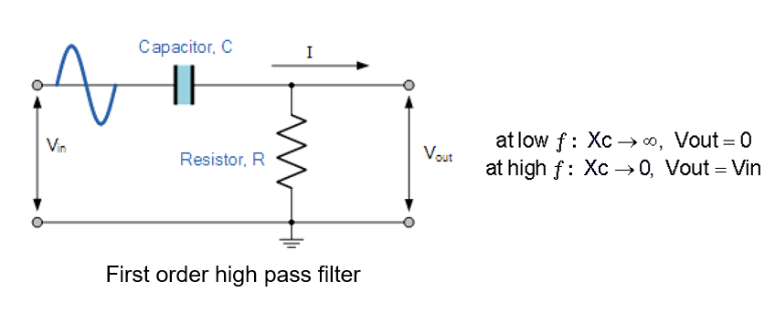

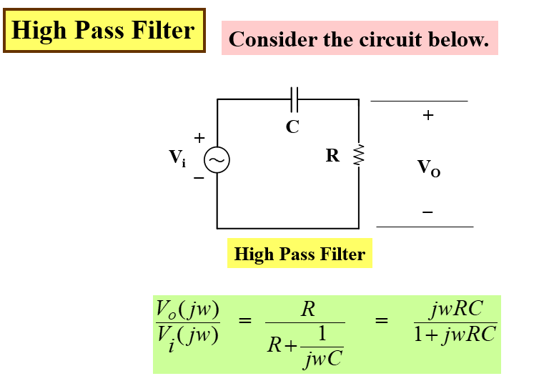

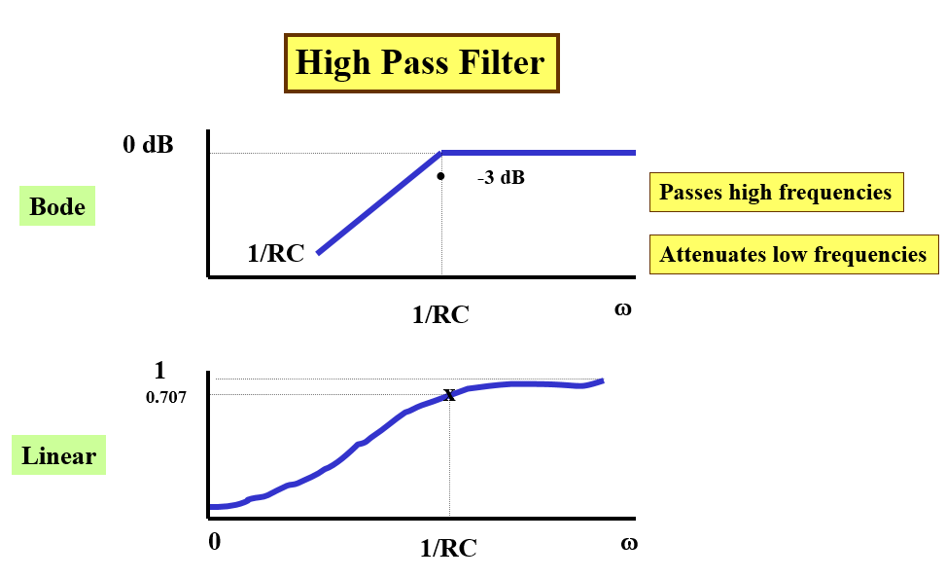

**(C) LOW PASS AS AN INTEGRATOR**

“If the time constant value is much greater than the time period of the input signal than the RC low pass circuit will act as an **Integrator**”

**RC >> T**

Under this circumstances the voltage drop across C will be very small in comparison to the drop across R.

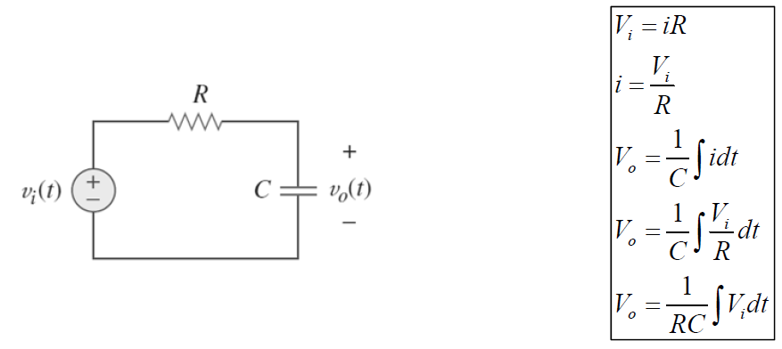

**(D) HIGH PASS AS A DIFFERENTIATOR**

“If the time constant value is much smaller than the time period of the input signal than the RC High pass circuit will act as a **Differentiator**”

**RC << T**

Under this circumstances the voltage drop across R will be very small in comparison with the drop across C. Hence we may consider that the total input Vi appears across C, so that the current is determined entirely by the capacitance.

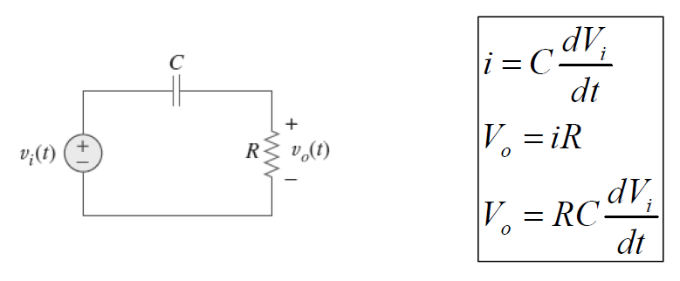

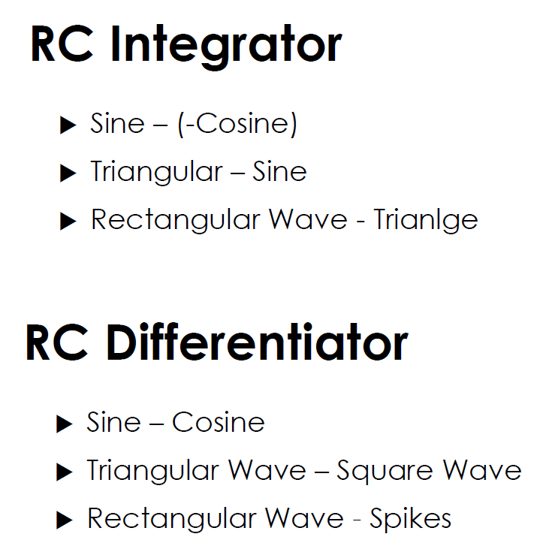

# Simulation screenshots

**Circuit Diagram of RC – High Pass Filter**

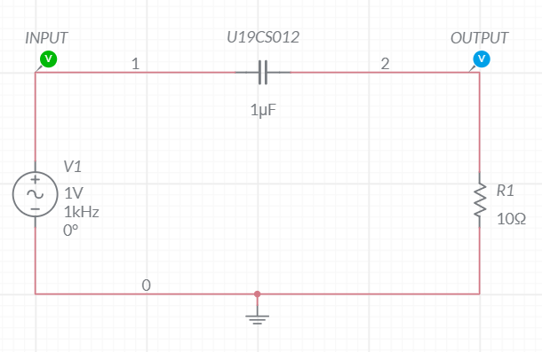

**Frequency Response Plot of High Pass Filter**

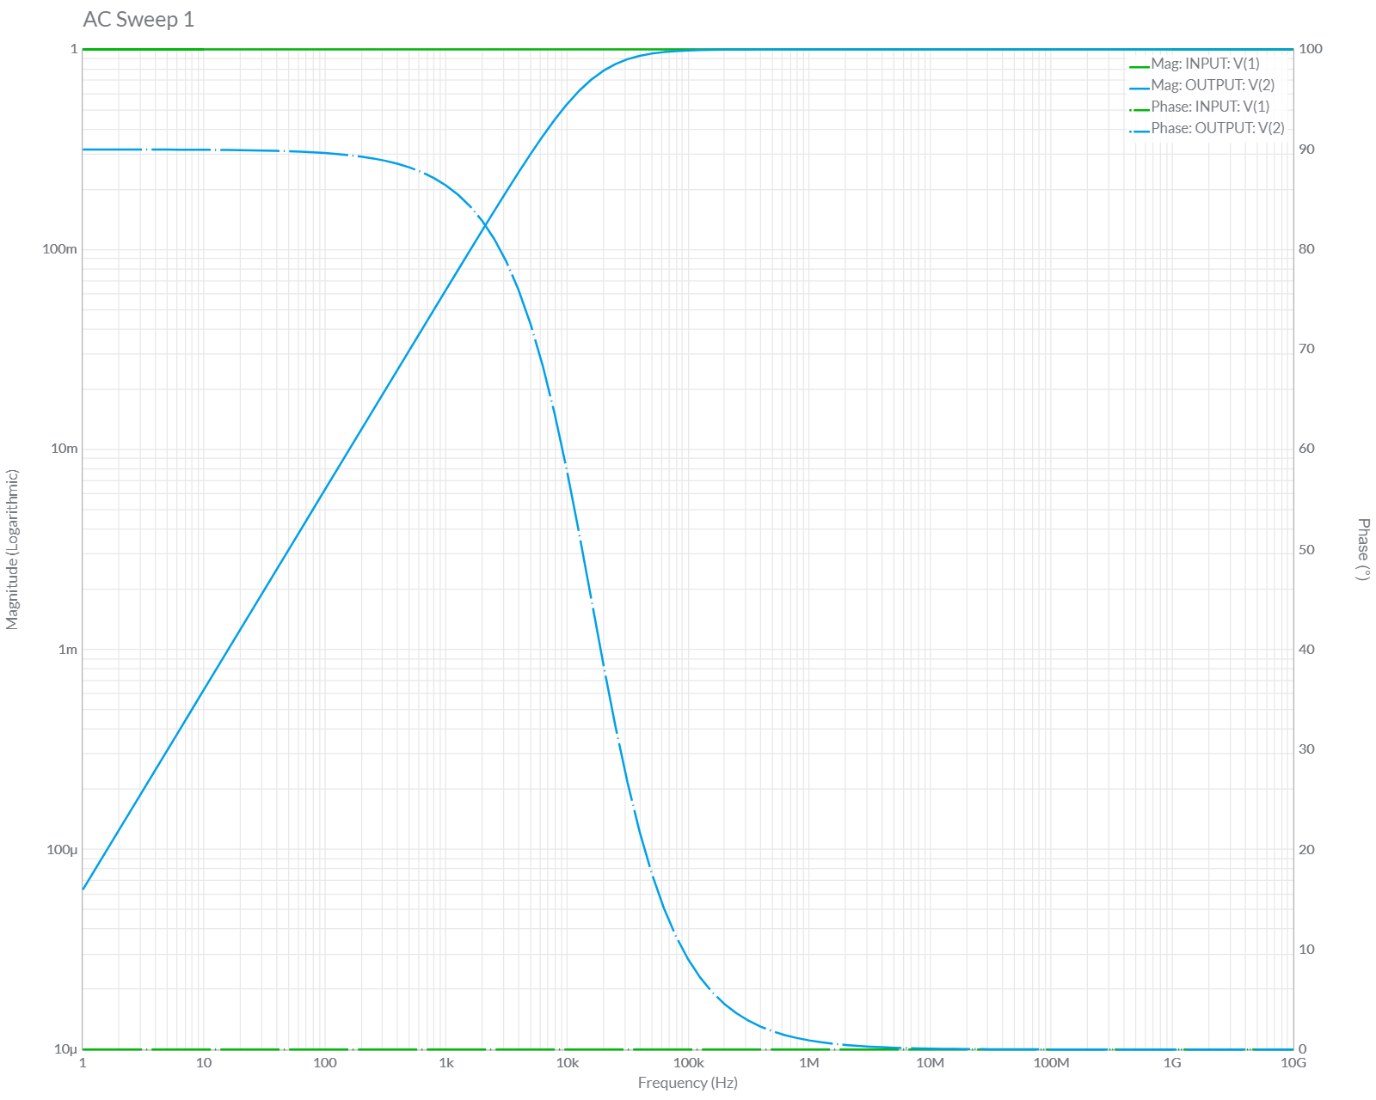

**Output of Differentiator [T>>RC]**

**Input – Sine Wave [Circuit Diagram]**

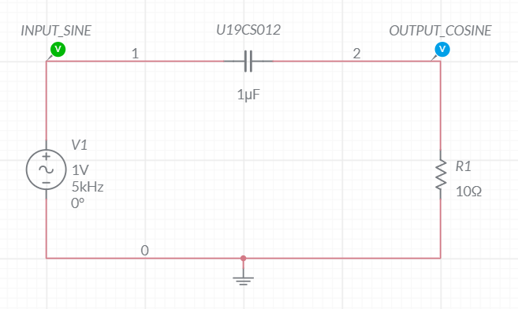

**Grapher Image [Differtiation of (Sine) = Cosine]**

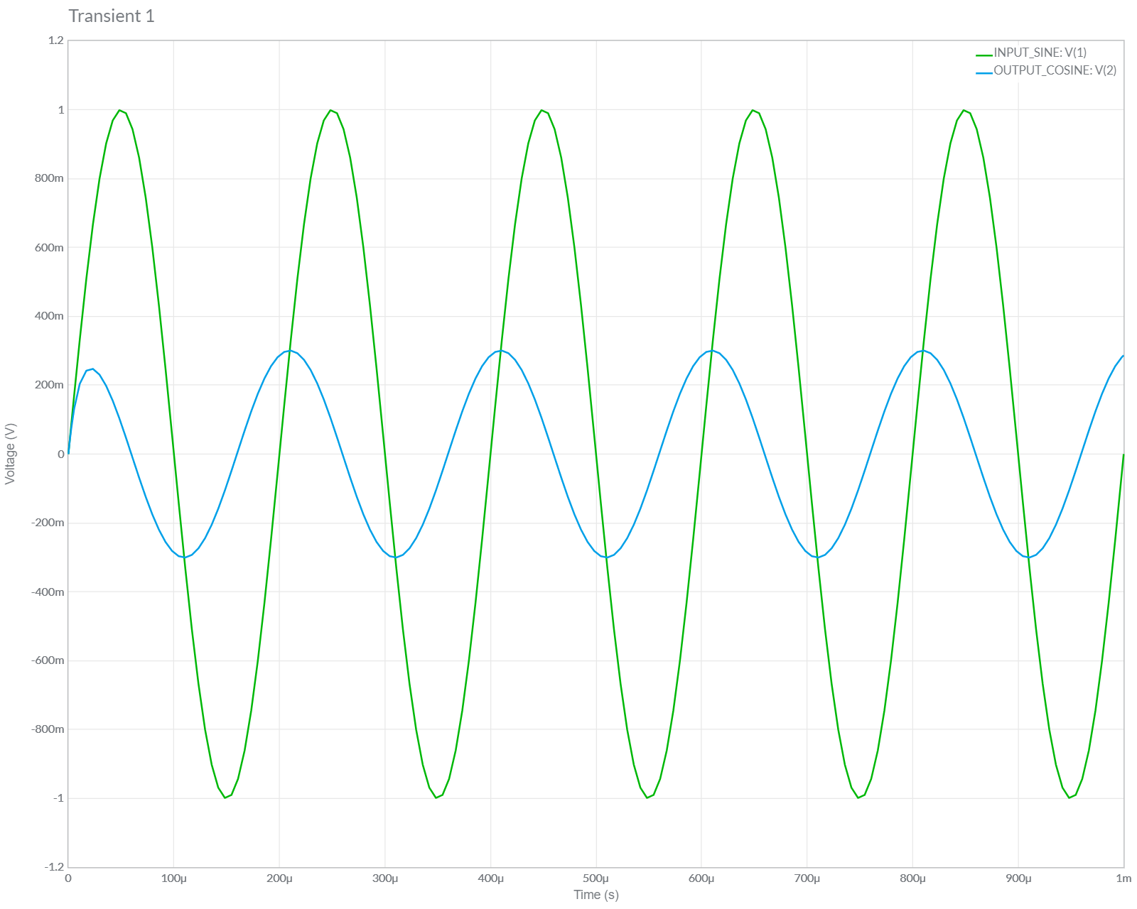

**Input – Triangular Wave [Circuit Diagram]**

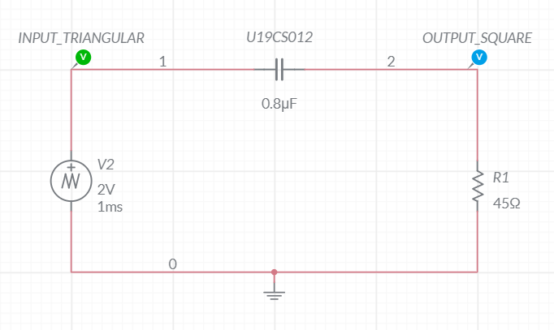

**Grapher Image [Differtiation of (Triangular) = Square]**

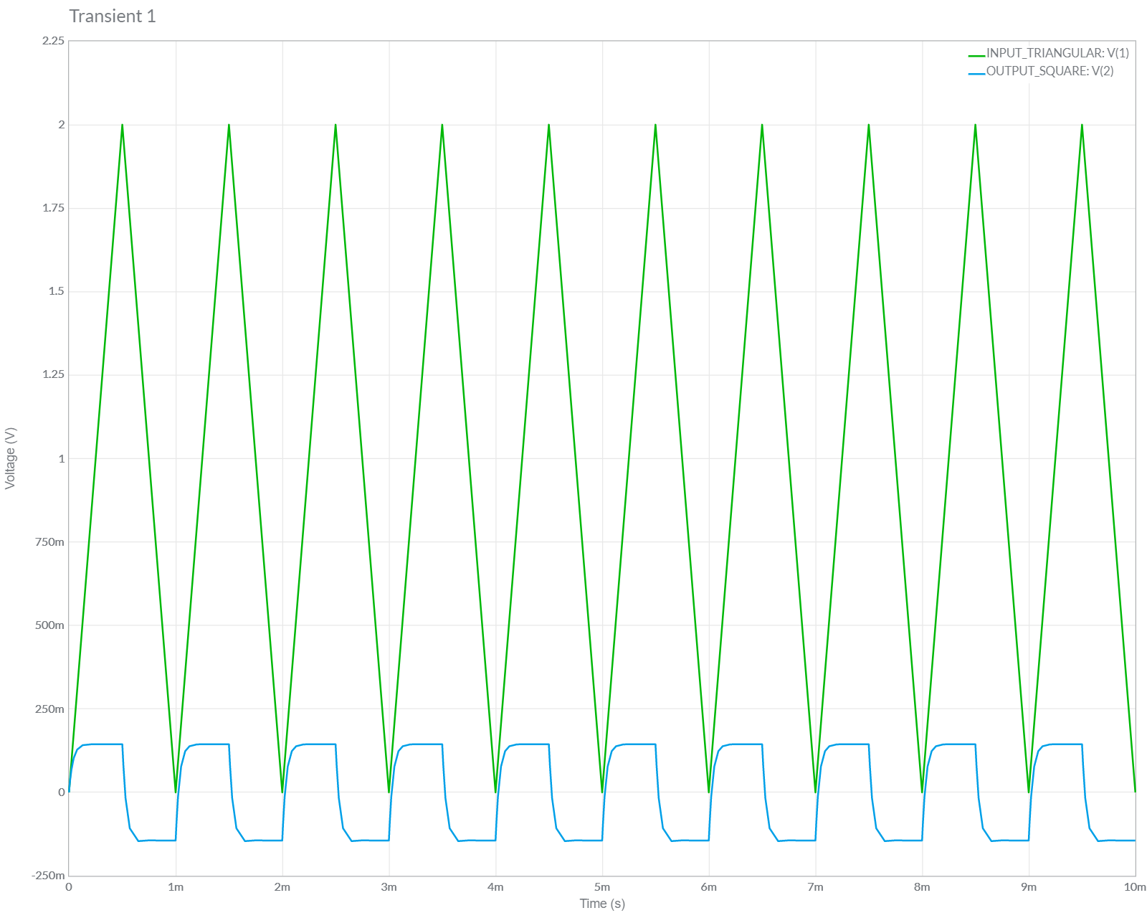

**Input – Square Wave [Circuit Diagram]**

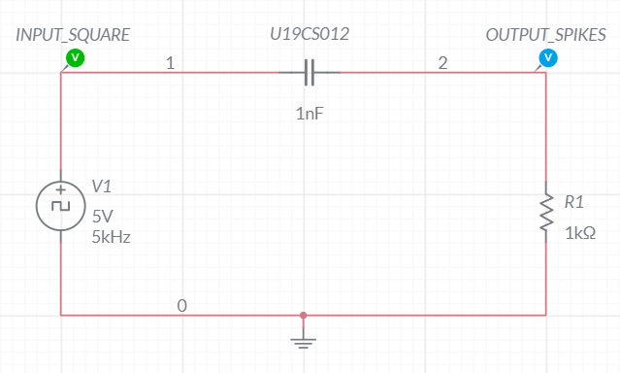

**Grapher Image [Differtiation of (Rectangular) = Spikes]**

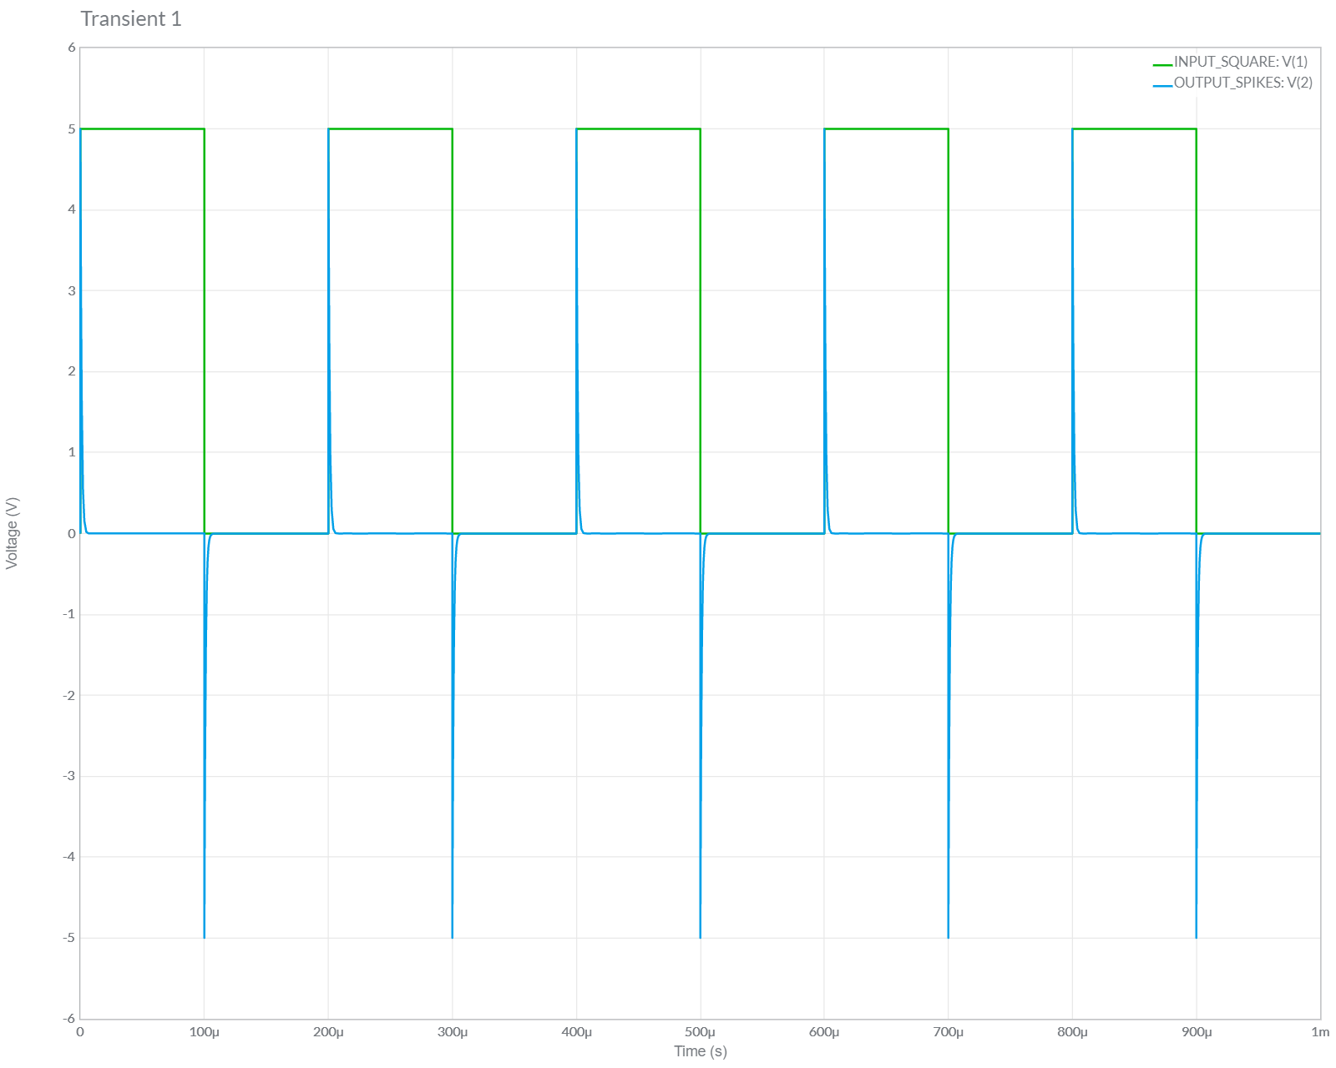

**Circuit Diagram of RC – Low Pass Filter**

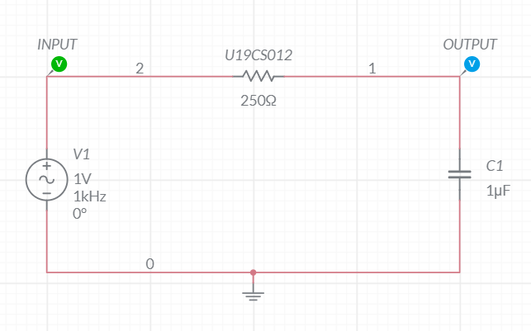

**Frequency Response Plot of Low Pass Filter**

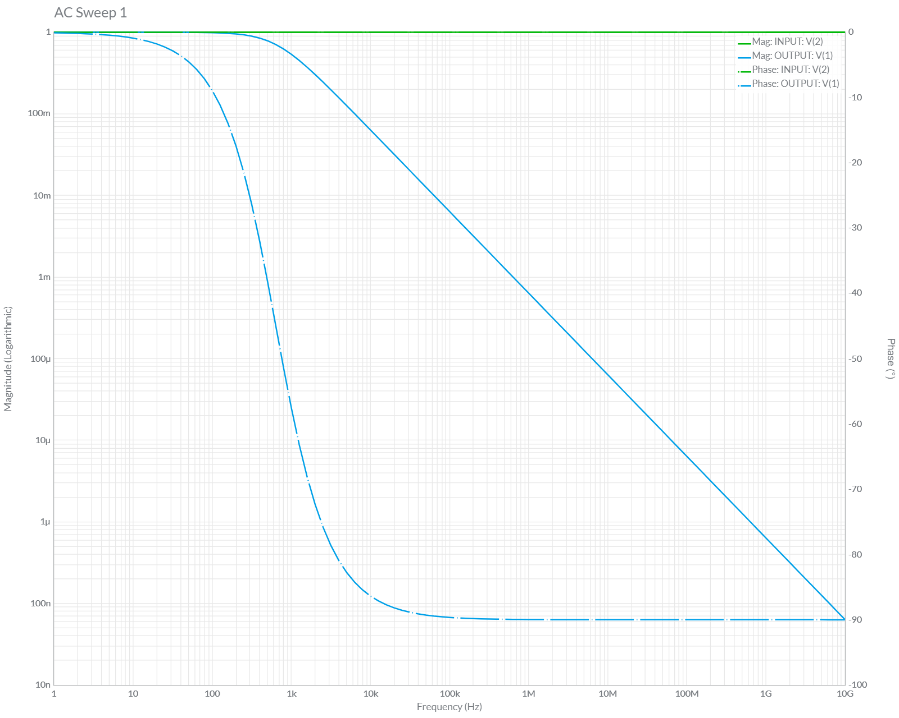

**Output of Integrator [RC>>T]**

**Input – Sine Wave [Circuit Diagram]**

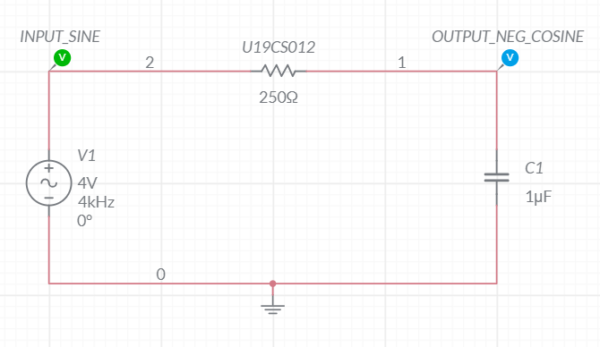

**Grapher Image [Integration of (Sine) = - Cosine]**

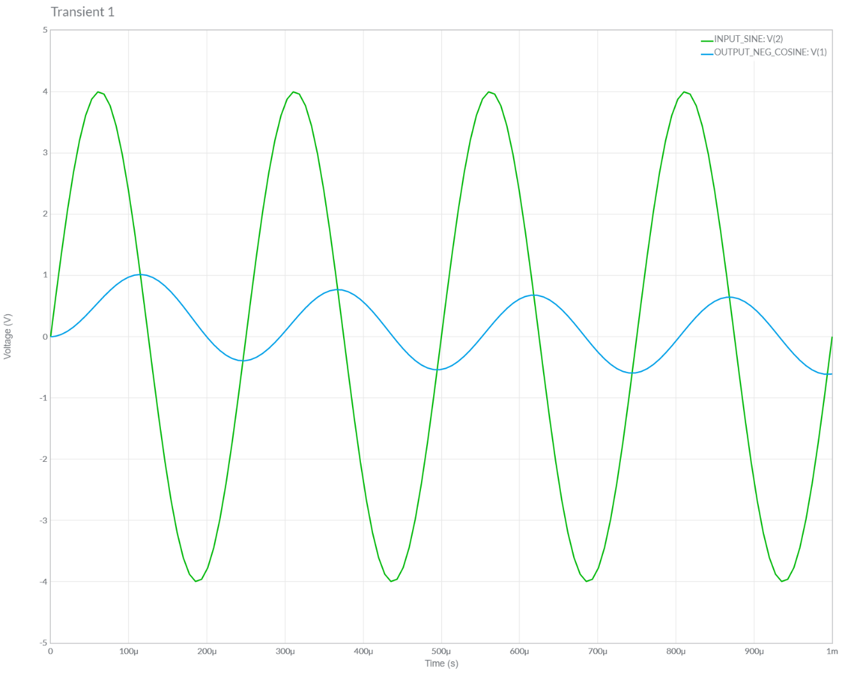

**Input – Triangular Wave [Circuit Diagram]**

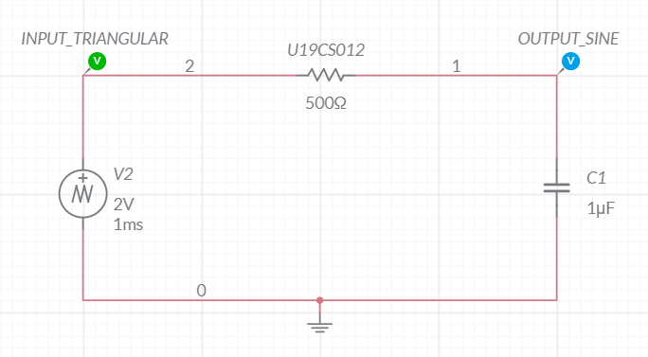

**Grapher Image [Integration of (Triangular) = Sine]**

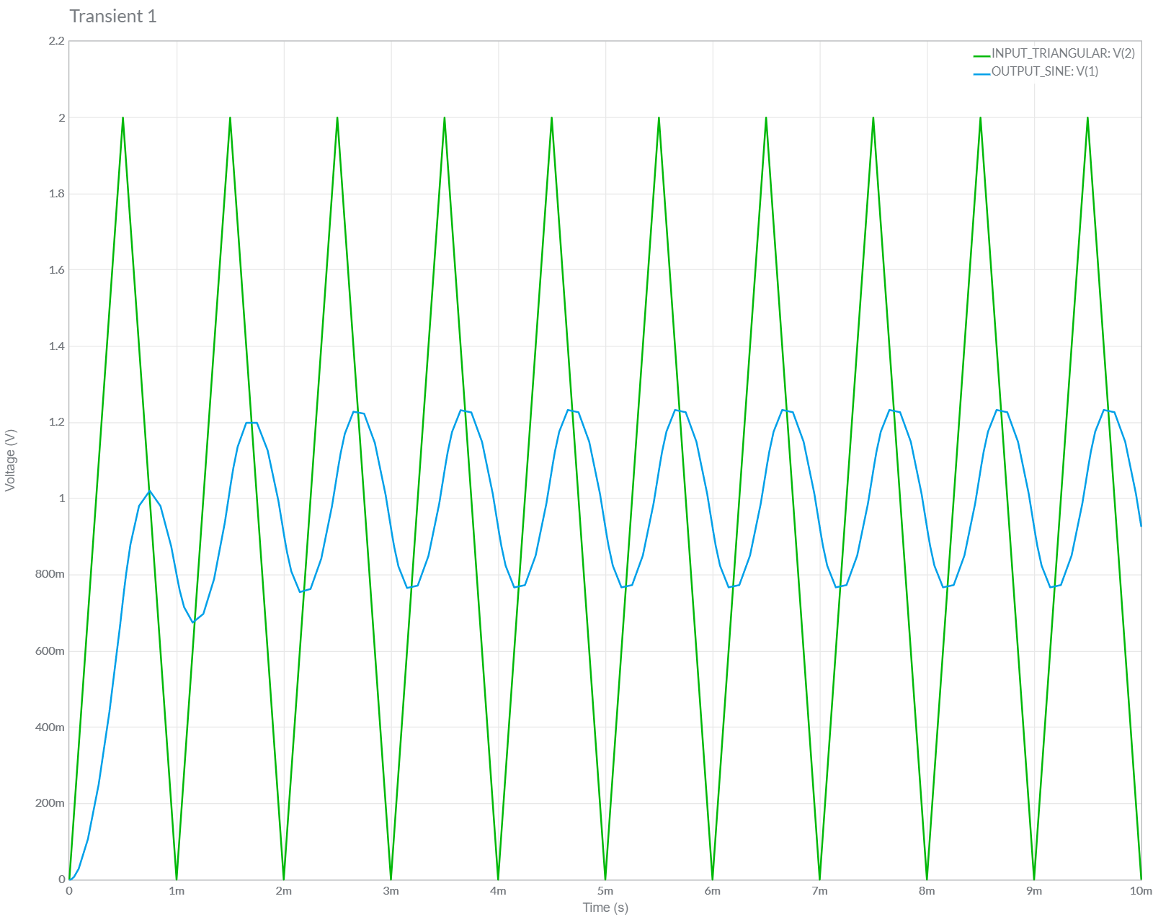

**Input – Square Wave [Circuit Diagram]**

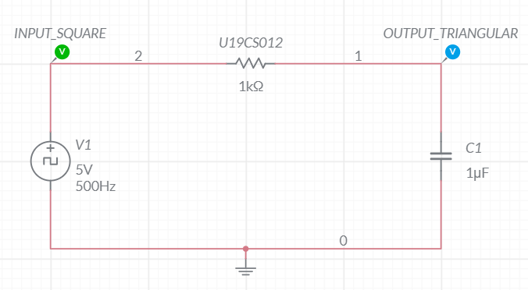

**Grapher Image [Integration of (Square) = Triangular]**

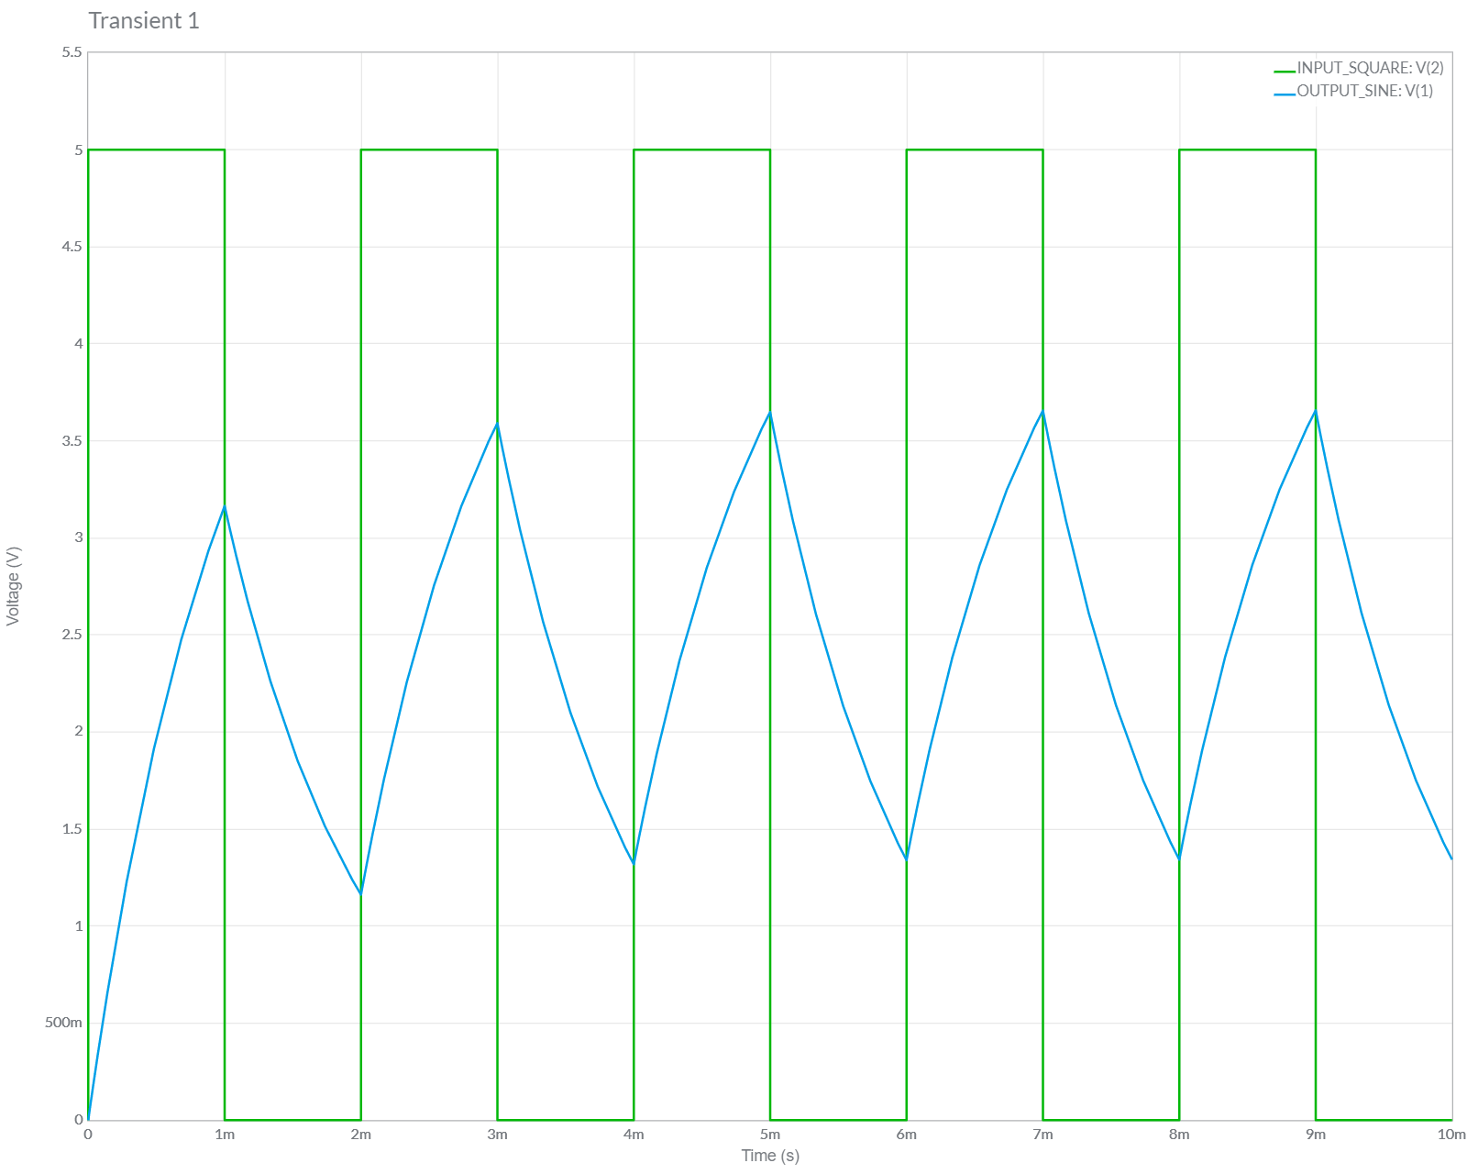

**Conclusions**

1.) In this Experiment, We have studied about Passive RC **High Pass** and **Low Pass** Filter and Also Observed the Working of **Low Pass Filter as an Integrator** and **High Pass Filter as a Differentiator**.

2.) We **Verified** the Theoretical Knowledge gained above by *implementing the above Circuits in all Three Input Cases:* ***Sine Wave, Triangular Wave and Square Wave*** in Multisim and successfully got the **Desired Output**.

Hence the *Experiment has Been Completed Successfully*.

**ASSIGNMENT-13**

U19CS012

1. Simulate an Active High Pass Filter Circuit [High Pass Filter using OPAMP]

[OPAMP with Amplification Factor = 3]

**Circuit Diagram [Multisim Implementation]**

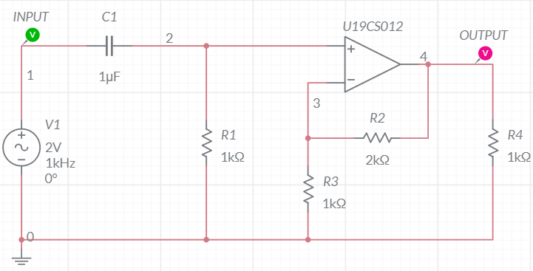

**Grapher Image [AC Sweep]**

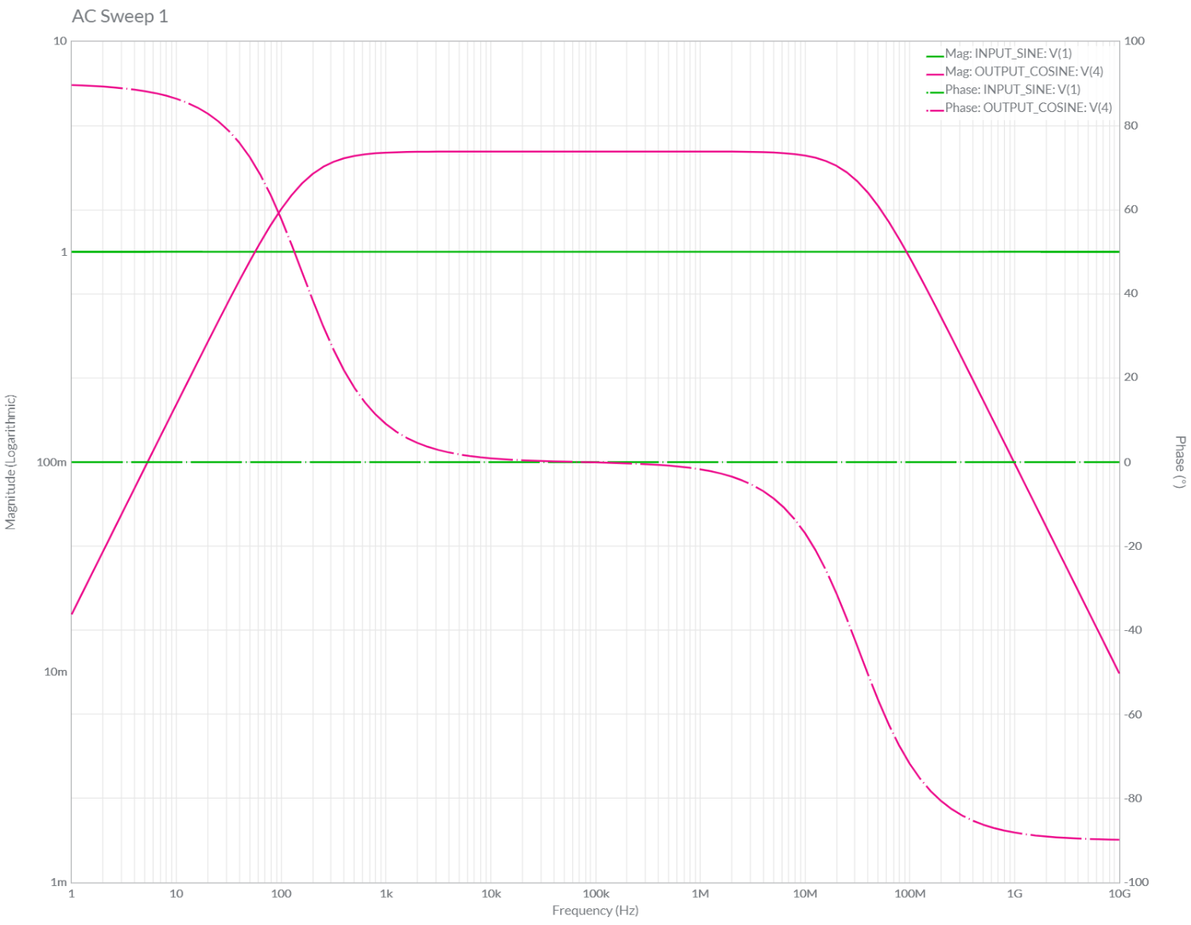

**Circuit Diagram [Offline Multisim Implementation]**

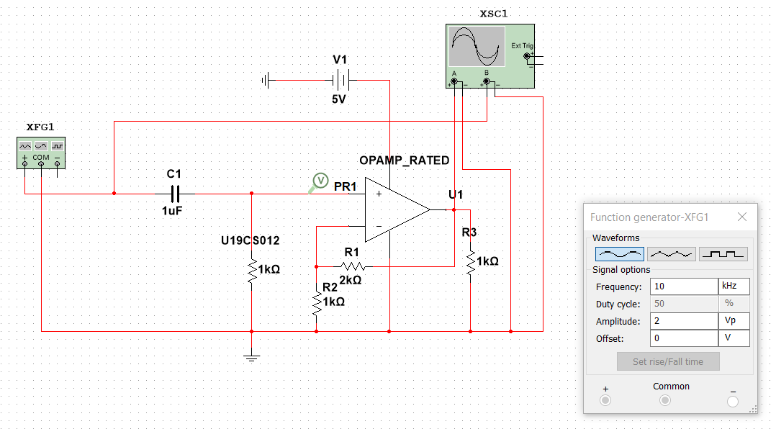

**Grapher Image [Offline Multisim AC Sweep]**

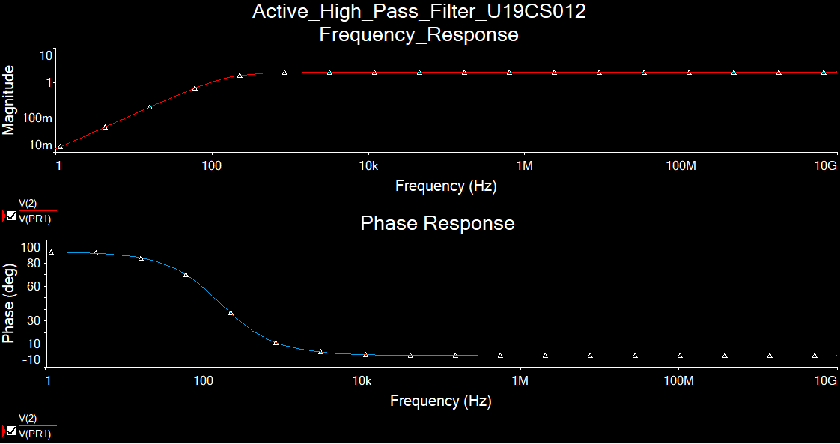

2. Simulate an Active High Pass Filter Circuit as Differentiator

[Differentiation of (Sine Wave) = + Cosine Wave]

**Circuit Diagram [Multisim Implementation]**

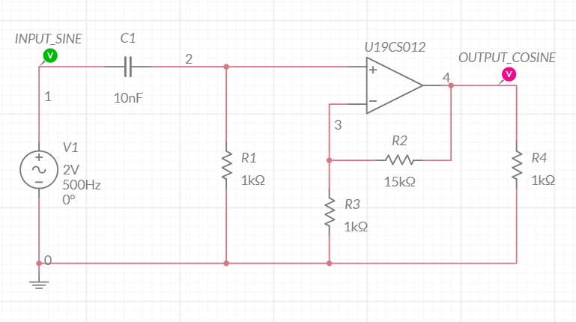

**Grapher Image [Transient]**

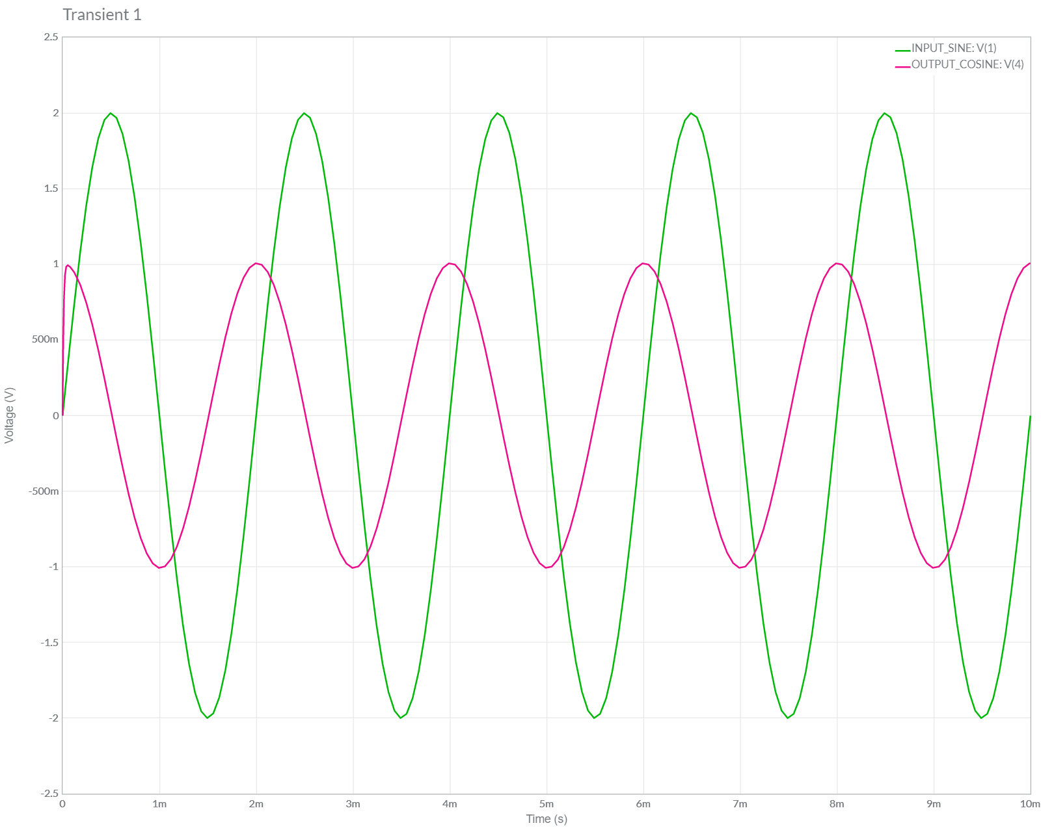

3. Simulate an Active High Pass Filter Circuit as Differentiator

[Differentiation of (Triangular Wave) = Square Wave]

**Circuit Diagram [Multisim Implementation]**

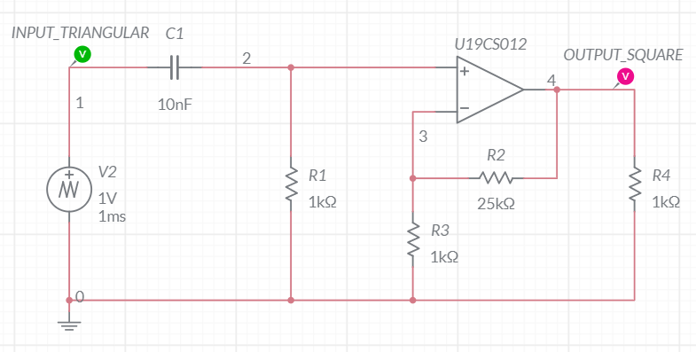

**Grapher Image [Transient]**

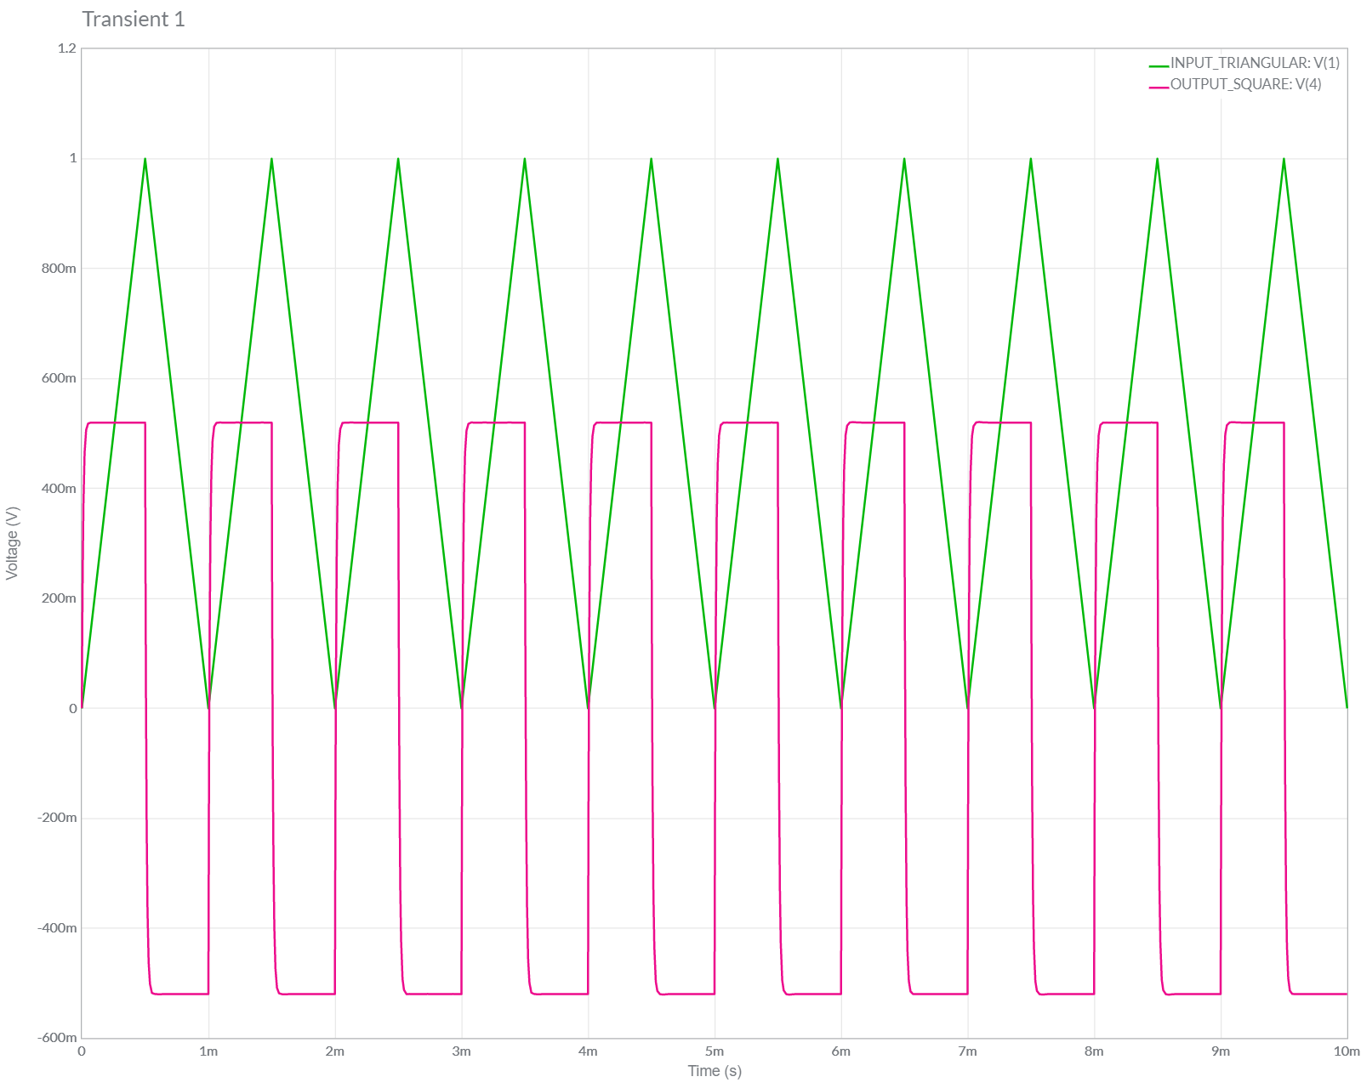

4. Simulate an Active High Pass Filter Circuit as Differentiator

[Differentiation of (Square Wave) = Spikes Wave]

**Circuit Diagram [Multisim Implementation]**

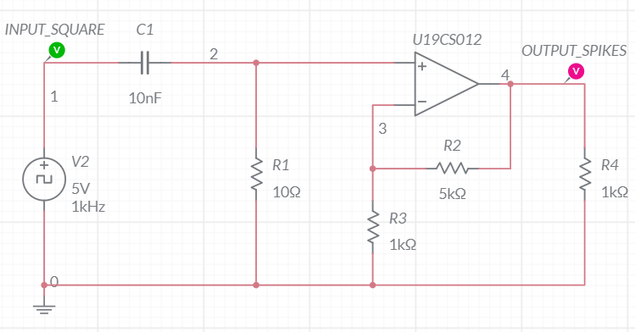

**Grapher Image [Transient]**

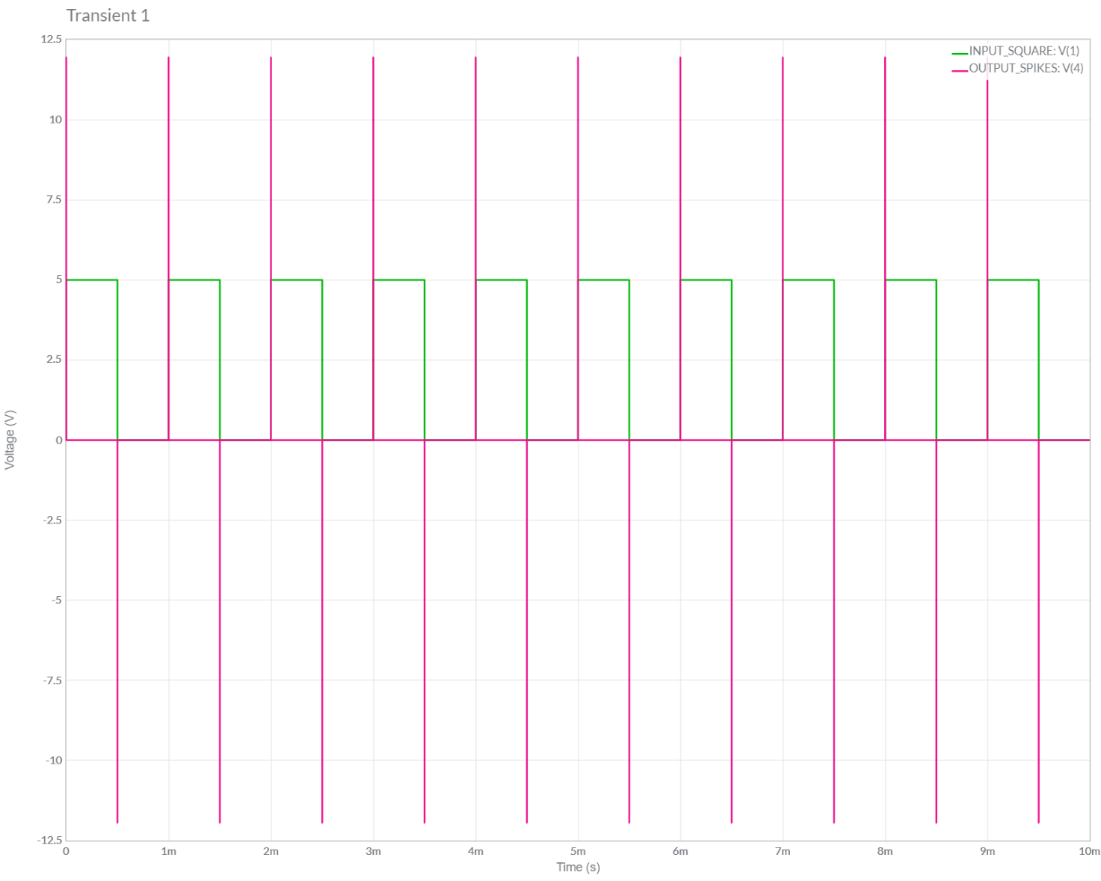

5. Simulate an Active Low Pass Filter Circuit [High Pass Filter using OPAMP] [EXTRA] [OPAMP as Buffer]

**Circuit Diagram [Multisim Implementation]**

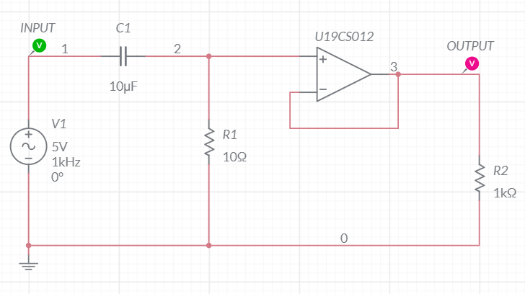

**Grapher Image [AC Sweep]**

